Child Abuse Prevention
Name __________________________________________ Time__________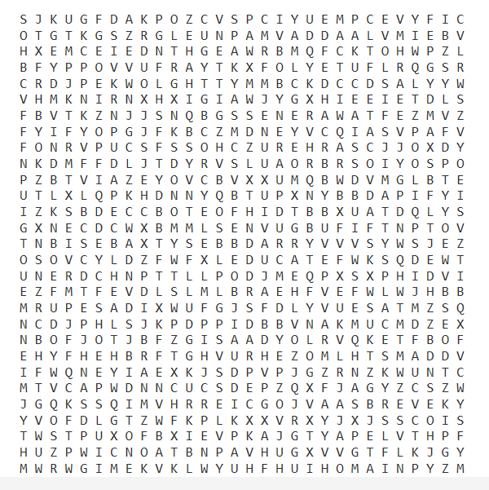

Find the below words in the puzzle above. Have fun and/or put a competitive spin on it and track your time to find all of the words. To enter- send to Nancy Sedbrook: your name, completed puzzle & time to complete by May 3rd.
ADVOCATE
AWARENESS
BELIEVE
EDUCATE
HEALTHY
LISTEN
LOVE
MATTYSPLACE
PREVENTION
ROLEMODEL
SAFE
STEPPINGSTONES
STRONG
SUPPORT

