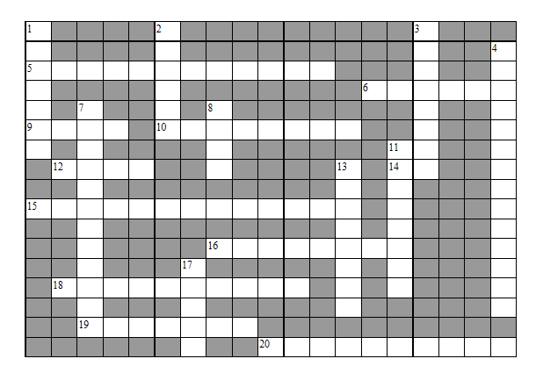

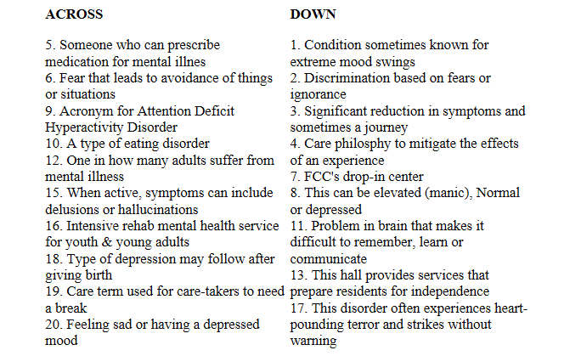

Name: Location: Program:

Send completed puzzle to Nancy Sedbrook, Development office, La Crosse

