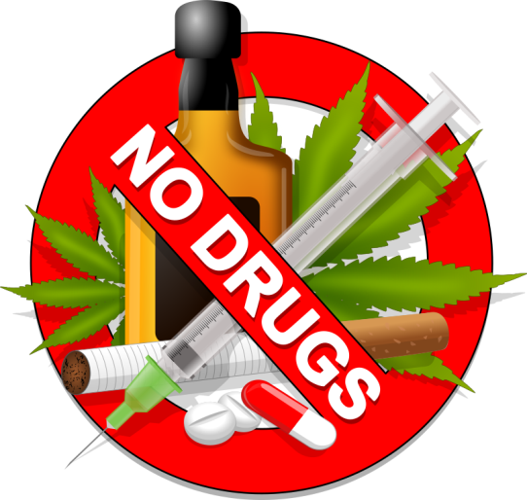**WESTERN HEALTHCARE**

**COALITION**

**FEBRUARY 29, 2016**

**Bringing Solutions together to Stop the Illicit Drug Epidemic**

**LOCATION: Waterfront –Cargill Center**

**328 Front Street South**

**La Crosse, WI 54601**

**TIME: Registration - 8:30AM**

**Conference - 9:00AM – 3:00PM**

**Lunch will be provided**

**NO COST TO ATTEND**

**REGISTRATION:** [rgraham@lacrossecounty.org](mailto:rgraham@lacrossecounty.org) Please Register by Feb. 17, 2016

Please provide: Name, Agency, email and if any special food needs

**QUESTIONS: Bob Ritger 608 780-6789** [**bob.ritger@dhs.wisconsin.gov**](mailto:bob.ritger@dhs.wisconsin.gov)

**Al Bliss** [**abliss@lacrossecounty.org**](mailto:abliss@lacrossecounty.org)

This will be a great chance to network and share ideas to work towards curbing this problem.  
Speaker from US Dept. of Justice

Special Guest Speaker at Noon

Open to: Law Enforcement, Healthcare, Public Health, Education, EMS and other Community Stakeholders