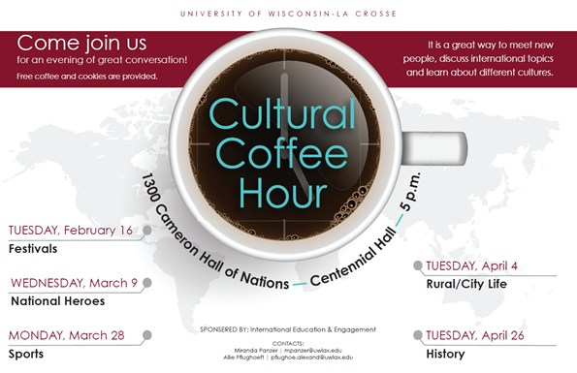

Cultural Coffee Hour, an event sponsored by International Education & Engagement (IEE), strives to promote global conversations amongst students, faculty, staff and community members over a cup of coffee or tea. The goals of Cultural Coffee Hour include creating awareness of international topics, and generate respect and appreciation of differences. Each semester, topics are selected for the five chosen event dates and are facilitated by international students and study abroad alumni.  Presentation formats vary by topic and could be a round table discussion or an individual presentation.

* **February 16 -** Festivals
* **March 9 -** National Heroes
* **March 28 -** Sports
* **April 4**- Rural/City Life
* **April 26 -** History

**When:**5 to 6 p.m. each date as identified above   
**Where:**1300 CN - Hall of Nations Centennial Hall

University of Wisconsin-La Crosse

**For more information contact Miranda Panzer at**[mpanzer@uwlax.edu](mailto:mpanzer@uwlax.edu)**or**[608.785.8016](tel:+16087858016)