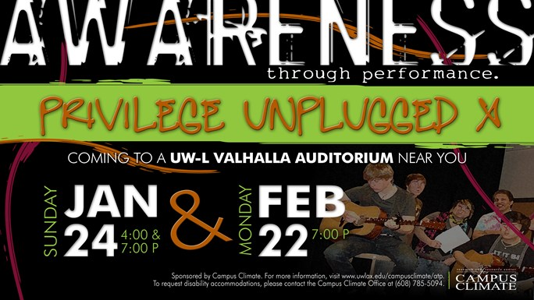

Using the stage as their forum for educating, student performers creatively explore, examine and dissect issues that are present in today's society.  This year's theme is "Privilege Unplugged IX".

Performances will take place in Valhalla, Cartwright Center at 7 p.m. on February 22. All performances are free of charge.

Join the conversation on [Facebook](https://www.facebook.com/pages/UW-La-Crosse-Campus-Climate-official/137994972919998) or [Twitter](https://twitter.com/UWLclimate) with the hashtag #UWLATP

*The mission of Awareness through Performance (ATP) is to promote greater consciousness around social justice, diversity, and climate issues on the UWL campus and beyond. Using the stage as our forum, we creatively challenge systems of privilege and oppression and strive to plant seeds of social responsibility, inspire critical thought, and spark a campus-wide conversation.*

**When:**7 to 9 p.m. Monday, Feb. 22   
**Where:**Valhalla, Cartwright Center-Gunning Addition

University of Wisconsin-La Crosse

**For more information contact Stephanie Bohlman at**[bohlman.step@uwlax.edu](mailto:bohlman.step@uwlax.edu)**or**[608.785.5092](tel:+16087855092)