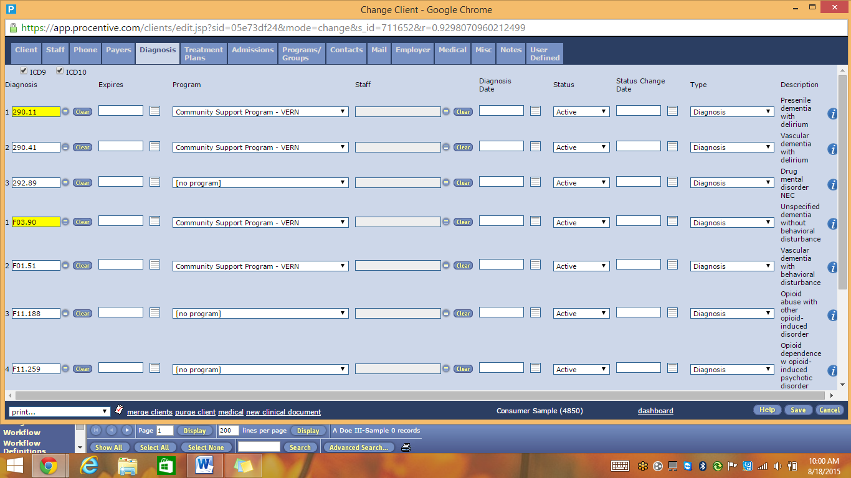
Both sets of codes will remain active until after all payers have made the transition and we no longer need ICD 9
The Client module, Diagnosis tab can show one or both code sets by using these check boxes

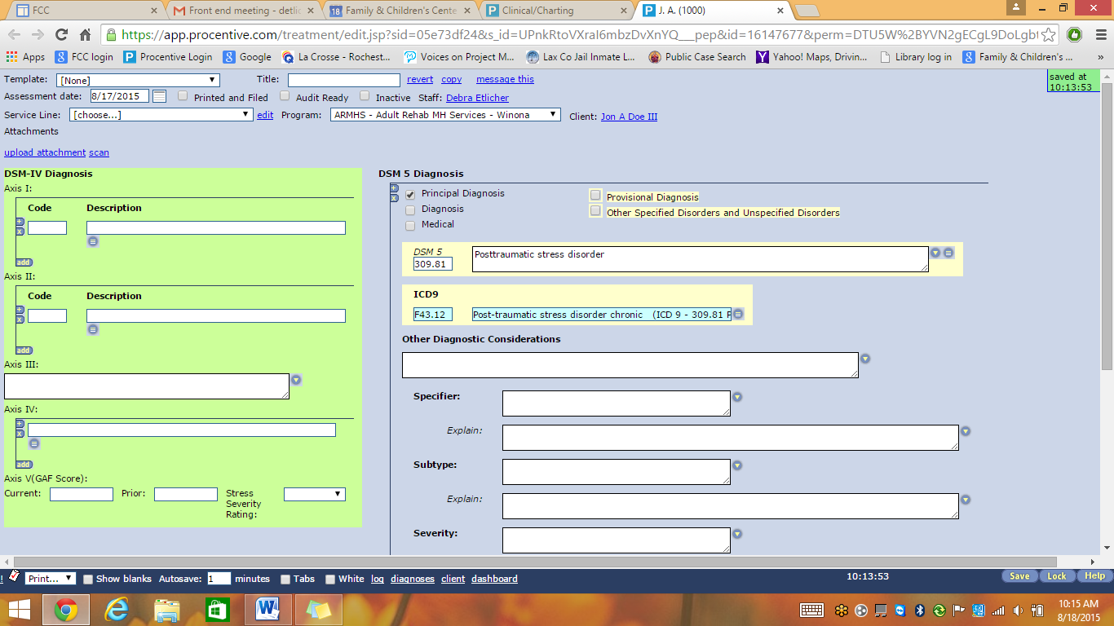
This pick list will contain both ICD 9 and ICD 10 codes
During the transition, clinical staff will include the ICD 9 code in parenthesis after the ICD 10 code
The DSM IV layout will no longer be available for most program documents
This field will be re-named ICD 10

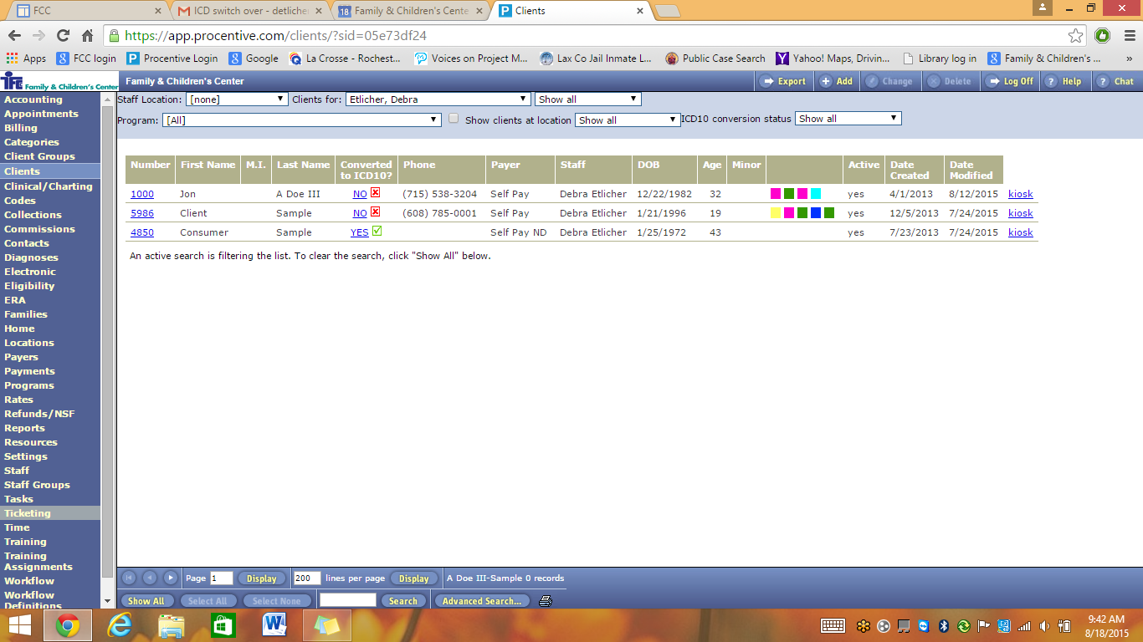
This column in the Client Module will indicate when the conversion process is completed for each client
As we begin to convert things to ICD 10, please be sure to change your filter to “show all”

